**Aim:**

To create a clone of a Virtual Machine (VM) and test it by loading the cloned VM using VirtualBox.

**Procedure:**

**1**. **Open VMware Workstation:**

* Launch VMware Workstation on the host system.
* Select the Virtual Machine you want to clone.

**2.** **Access Cloning Option:**

* Right-click the VM → Select **Manage → Clone**.
* The Clone Wizard will appear.

**3.** **Choose Clone Type:**

* Select **Create a full clone** (independent copy with its own virtual disk) or **Create a linked clone** (depends on the parent VM and shares virtual disk).
* Click **Next**.

**4.** **Name the Cloned VM:**

* Provide a unique name and storage location for the cloned VM.
* Click **Finish** to complete cloning.

**5.** **Test the Cloned VM:**

* The cloned VM will appear in the VMware Workstation library.
* Power on the cloned VM and verify it boots successfully.
* Perform basic operations (install software, change settings) to confirm it works independently of the original VM.

**OUTPUT:(ORIGINAL VM)**

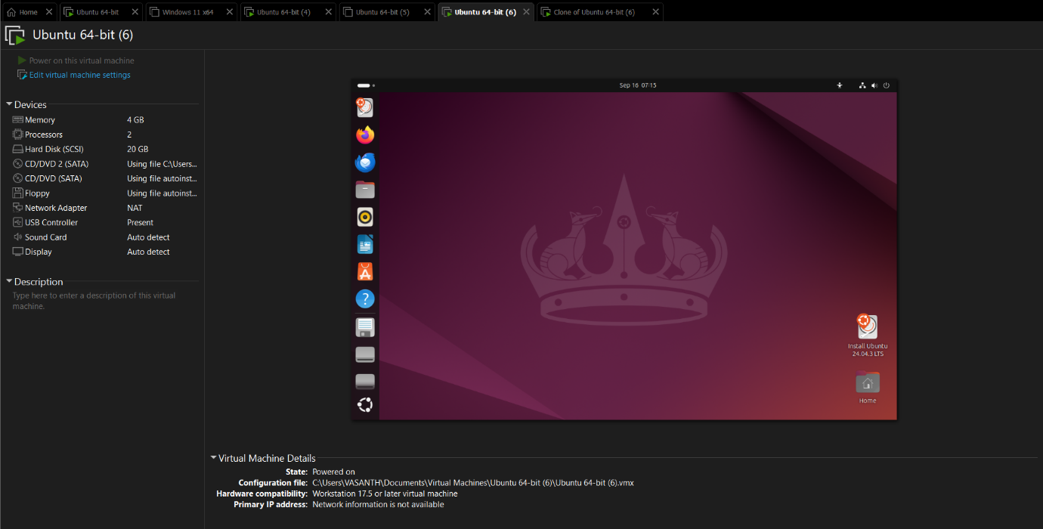

**OUTPUT: (Cloned VM)**

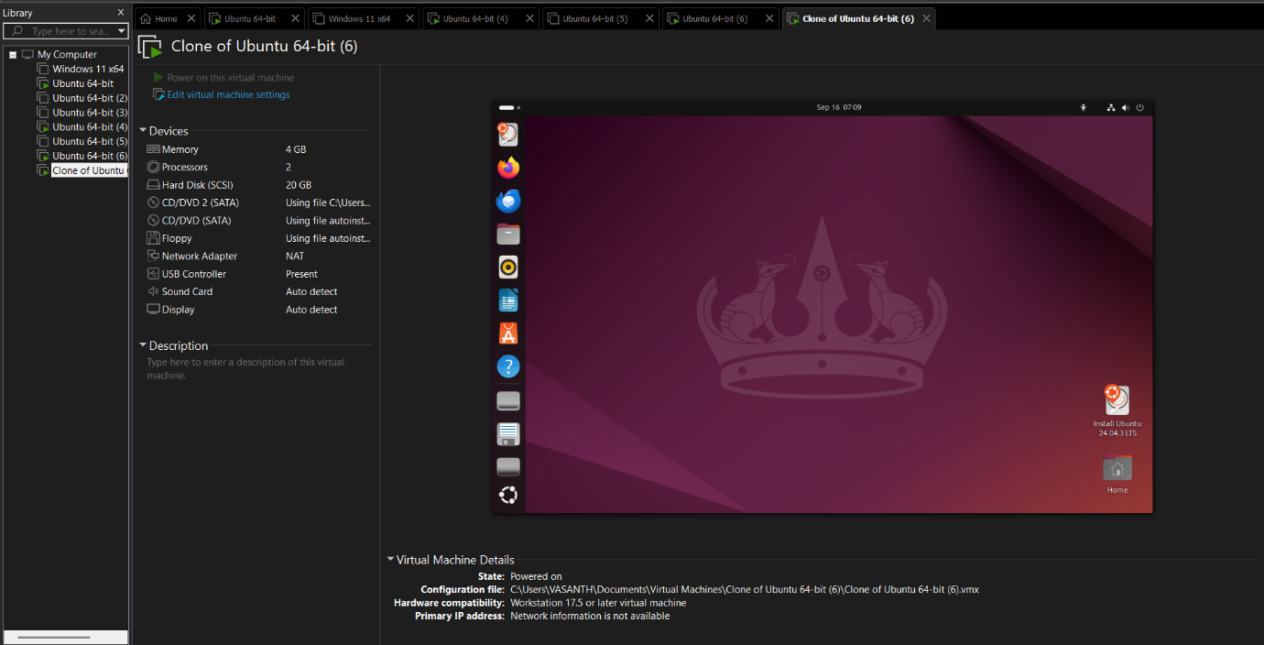

**Result:**

A Virtual Machine was successfully cloned using VirtualBox. The cloned VM booted properly and functioned as an independent copy of the original machine.